**Title of the article [Times New Roman, 14, bold, sentence case, centred]**

**[1 enter]**

**First Name [Times New Roman, 12, bold, capitalized, centred] LAST NAME* [Times New Roman, 12, bold, uppercase, centred]**

*Name of the University, City/State, Country [Times New Roman, 10, italic, capitalize each word, centred]*

*ORCID ID:*

*\*Corresponding author, e-mail address [Times New Roman, 10, italic, capitalize each word, centred]*

**[1 enter]**

**First Name [Times New Roman, 12, bold, capitalized, centred] LAST NAME[1] [Times New Roman, 12, bold, uppercase, centred]**

*Name of the University, City/State, Country [Times New Roman, 10, italic, capitalize each word, centred]*

*ORCID ID:*

*e-mail address [Times New Roman, 10, italic, capitalize each word, centred]*

**[1 enter]**

**Abstract. [Times New Roman, 10, bold, capitalized, justified]** *The abstract length should be a maximum of 300 words. The Abstract is written in Times New Roman 10, italics. The text is justified and single-spaced (spacing 1). The abstract must include sufficient information for readers to judge the nature and significance of the topic. The abstract should include: a) a brief introduction to the topic of the paper; b) an overview of the current state of the scientific literature on the topic; c) a presentation of research methodology and research questions; c) a short presentation of main results and the implications for the field; d) highlights of the contribution brought by the paper to the field of studies. [Times New Roman, 10, italic, justified]*

**[1 enter]**

**Keywords**: **[Times New Roman, 10, bold, capitalized, justified]** keyword 1, keyword 2, keyword 3, keyword 4, keyword 5. The keywords should be 5-7. They should be consistent with the title and the abstract. [Times New Roman, 10, no formatting, justified].

[1 enter]

**How to cite**: *here the editor will insert the text after the final manuscript is processed.*

[1 enter]

**Introduction [Times New Roman, 12, bold, capitalise first word, justified]**

The first paragraph starts exactly at the left margin – indentation none.

The rest of the paragraphs are written with one tab like this one – indentation 1.27 cm [Times New Roman, 10, no formatting, justified]. All margins should be set at 2 cm (the template margins are already set to these specifications). Use DIN A4 Format (297 x 210 mm)

The entire paper will be written using Times New Roman font type, 10 point (except for chapter titles, table titles, figure titles and sources), alignment: justify, line spacing: 1. The paper should have a minimum of 4 maxim 8 pages, even number. Please use normal capitalization within the text and do not use boldface for emphasis. Italics are acceptable. All headings should use initial capitals only, except for the use of Acronyms. Do not use multiple columns. Do not include bullet lists or numbered lists unless necessary. Do not use more than three levels of headings and do not number the headings.

The introduction should explain all the necessary ideas to introduce the reader to the topic of the paper and the research performed by the author(s). It shows the importance of the subject and the approach used by the author in dealing with it. The author must formulate clearly the research question and the main hypotheses considered in this research.

[1 enter]

**Literature review [Times New Roman, 12, bold, capitalise first word only, justified]**

***Subtitle [Times New Roman, 11, bold, Italic, capitalize first word, justified]***

The first paragraph starts exactly at the left margin – indentation none.

The rest of the paragraphs are written with one tab like this one – indentation 1.27 cm [Times New Roman, 10, no formatting, justified].

*Sub-subtitle* *[Times New Roman, 11, Italic, capitalize the first word, justified]*

The first paragraph starts exactly at the left margin – indentation none.

The rest of the paragraphs are written with one tab like this one – indentation 1.27 cm [Times New Roman, 11, no formatting, justified].

In this section, the author provides the background literature explaining the state-of-the-art in the research field of the current research. The author should consider all significant publications and construct a synthesis of the different viewpoints expressed by different authors. Also, the author(s) should provide the working definitions of the basic concepts used in the paper and the main ideas, models or theories found in the related literature. The literature review should reveal the gap between the extant literature and the new perspective or model presented in the paper.

[1 enter]

**Methodology [Times New Roman, 14, bold, capitalise first word, justified]**

This section explains the research methods, hypotheses, and the arguments used by the author,. The author should explain how the research has been designed and conducted.

The author should make references to some previous research similar to the current one if that is the case. Also, the author should mention the software programs used for processing data, if it is the case.

[1 enter]

**Results and further discussions**

In this section, the author(s) presents the main findings of his/her research. It is important to use critical thinking to analyze realistically the results obtained. It is recommended to compare the results of the present research with results obtained in similar research, by using the literature in the domain. If the paper presents a theoretical model or theory, the discussion should be about the way the new conceptual contribution can be applied and how it compares with some similar models or theories.

For a better explanation, the author may use graphical illustrations or tables.

[1 enter]

**Figures and tables**

*Figures* and *tables* should be placed as close to their reference point in the text as possible. All figures and tables must have titles and must be referenced from within the text. Also, all figures and tables must be accompanied by their source (if the illustration is the results of the authors’ research it should state “Source: Authors’ own research results/contribution”). It is advisable to include colour diagrams and pictures to enhance readability. The figure’s title has to be self-explanatory so that the figure and its legend are understandable without reference to the text. An image example is presented in Figure 1. Images must be inserted as jpg files.



**Figure 1:** Title of figure (Times New Roman, 10 pt, left aligned)

Source: Author’s own contribution

*Tables* should be self-contained and complement, but not duplicate, information contained in the text. Column headings [Times New Roman, 10, bold]have to be clear and brief and present the units of measurement in parentheses. If the table contains data that has not been generated by the author’s own research, then the source must be cited as in the text below the table and also in the reference section. The tables should not be pictures but in editable format! Any abbreviations used in the column heads or rows must be explained as a note below the table. The content of the table should be written in Times New Roman, 10, no formatting. Tables and images should be referred to in the text, the tables should be formatted as below:

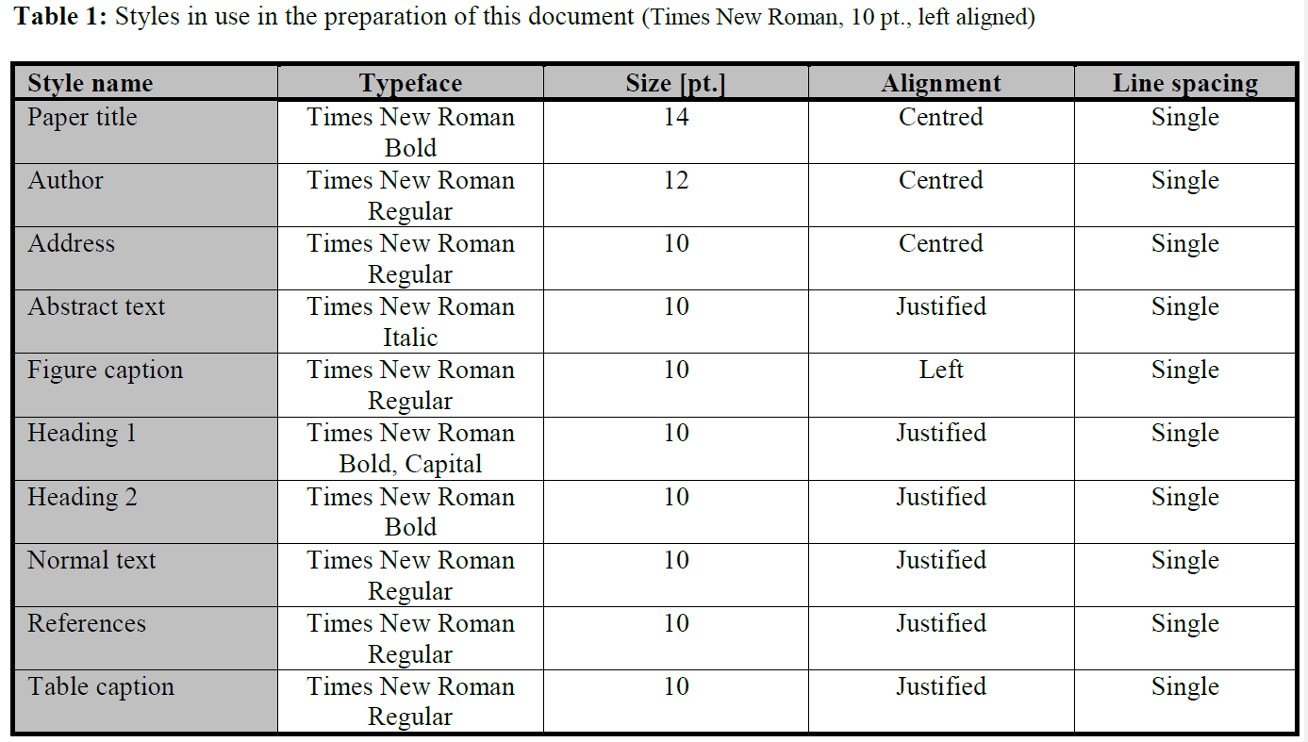

Source: Authors’ own research. [Times New Roman, 10, aligned to the right].

Make sure all the tables have sources!!!

Equations should be centered and numbered consecutively, from 1 upwards. Use Microsoft Equation Editor. There should be one line spacing before and after.[Time New Roman, 10 pt.]

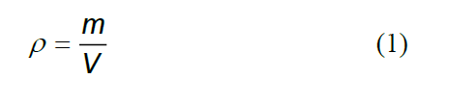

[1 enter]

**Conclusion**

A conclusion section is required. Conclusions should provide a synthesis of the main contributions of the paper, and discuss the importance of the work. It is important to emphasise the practical implications of the research. Also, the author should indicate some major limitations of the present research.

[1 enter]

**References**

References should follow the APA referencing style. References should not exceed 25 titles and 1 page. References should be listed at the end of the text. References should be indicated in the text by a sequence number in square brackets [1].

They should be numbered in the order in which they appear in the text. All references should be complete so that they can be found by anyone wishing to follow them up. ISBN/ISSN numbers should be provided where they have been allocated. For books, the place of publication is also required. Please follow the examples:

[1] Surname, N.; Surname, N.: *Name of Book (in Italics)*, Publisher, ISBN, Place of Publication, (YYYY)

[2] Surname, N.. & Surname, N.: Name of paper or Chapter, In *Name of Book (in Italics)*, Publisher, ISBN, Place of Publication, (YYYY), pp. xxx-yyy

[3] Surname, N..; Surname, N. & Surname, N.: Title of conference paper, *Proceedings of xxx xxx*, Surname, N. (Ed.), pp. xxx-yyy, ISBN, conference location, Month and Year, Publisher, City, (YYYY)

[4] Surname, N.: Name of paper, *Name of Journal (in Italics)*, Vol. (YYYY) No., pp. xxx-yyy, ISSN

[5] Surname, N.; Surname N. & Surname N.: Name of Paper, *Available from* http://www.exact-address-of-site *Accessed:* YYYY-MM-DD

(For three or more authors, use the Surname, N.. of the first author plus et al).

[1 enter]

**Appendix** (if needed)

Please note that submissions not complying with these guidelines will be rejected on formal grounds!

1. The maximum number of authors per paper is four!