## How to submit a paper to ICMIE Conference?

*Guide on how to use the online submission platform.*

The conference is using an online platform to manage all submissions and to have prompt communication with authors.

To be able to use all the facilities, first, you need to click on the SUBMIT button from the conference’s homepage.

The following window will be opened for you.

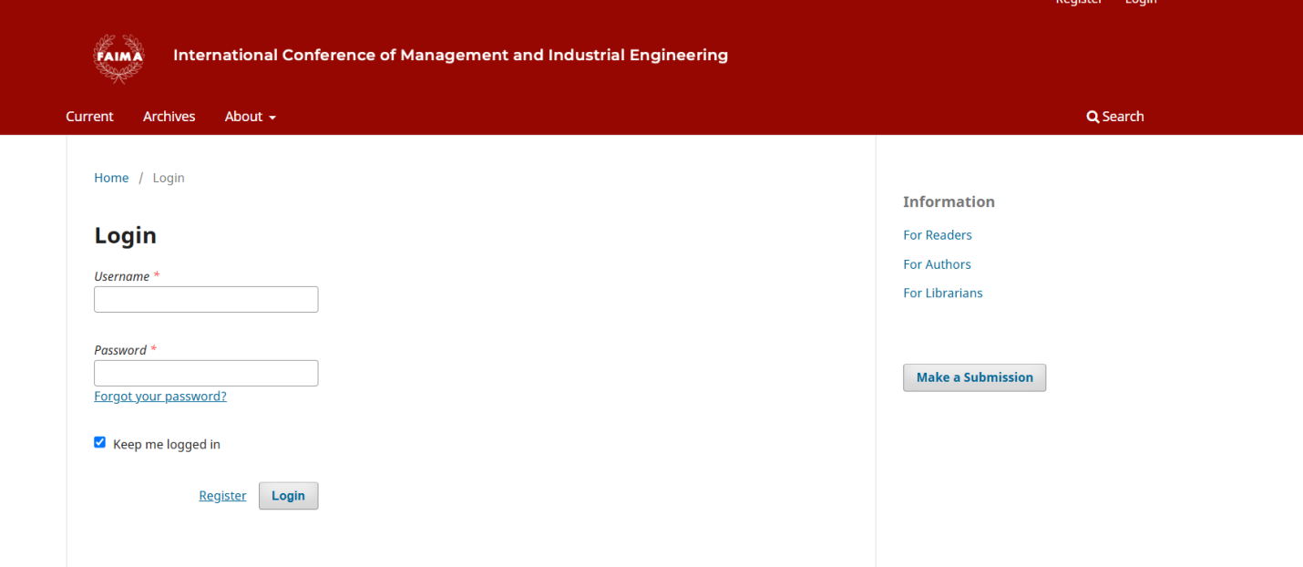

Fig.1 Main page of the online platform (<https://faima.upb.ro/ojs/index.php/icmie/user>)

Click on Register (see Fig.1) and fill in all the requested information (see Fig.2). It is important for us that you be able to connect also with your ORCID iD. If you don’t know what is ORCID iD please access the “*What is ORCID*?” link for more details.

For registration, you should provide the information (see Fig.2) and create for yourself an account using your email, an account ID and a password. Every time you want to check your submission status you need to log in with your credentials (account ID and password).

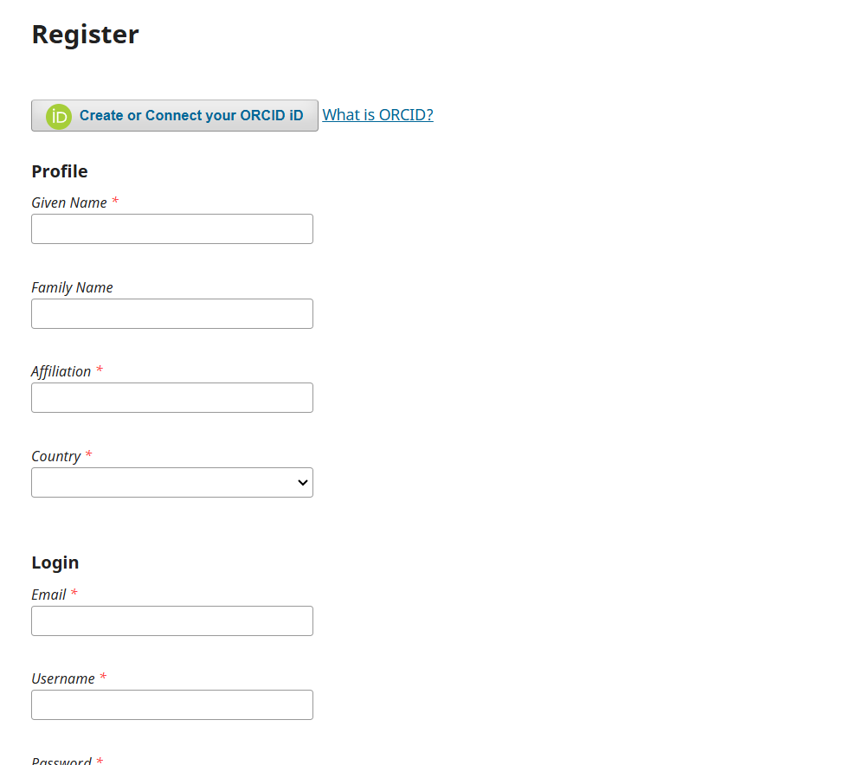

Fig. 2 Registration form

Please fill in all the lines, and check the 2 boxes(author and reader)

The registration process ends when you click the **Register** button ( see Fig.3)

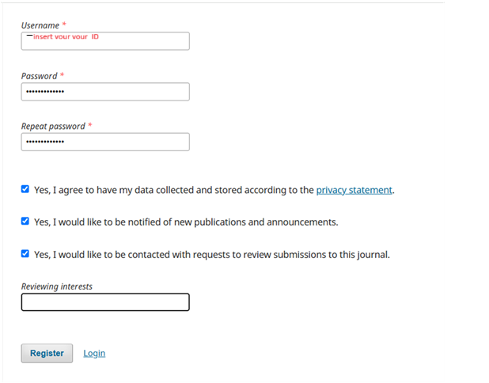

Fig. 3 Final part of the registration form

Once the registration is completed, you will be redirected to the personal page ( see Fig.4). As you can see no submission was found, because you didn’t have one, you just registered.

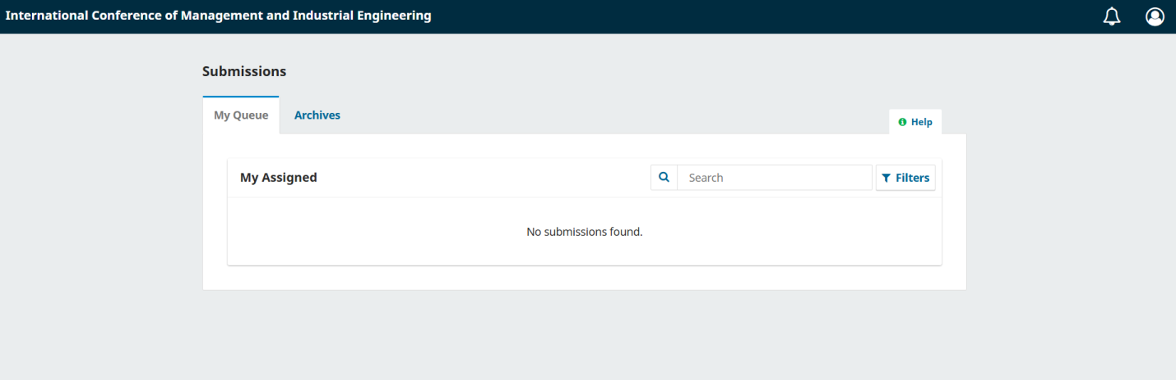

Fig.4 Personal page, after registration

If you are ready to submit your abstract(s), go to the main page (see Fig. 5) and click on “Make a submission” button on the right side of the window. You may find, as you can see, the Submission Preparation Checklist which is necessary to go through before submitting an abstract/paper.

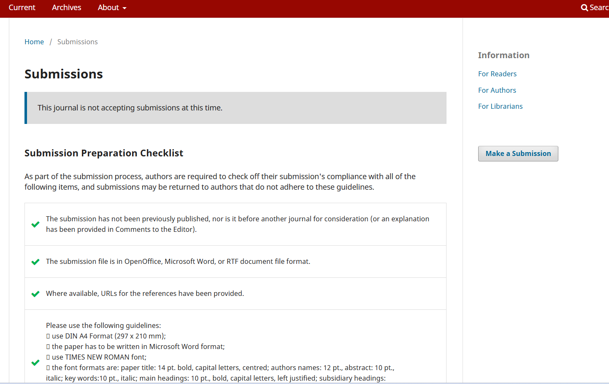

Fig. 5 Submission page

When you are ready, click the button **New Submission** as you can see in the right part of the main window.

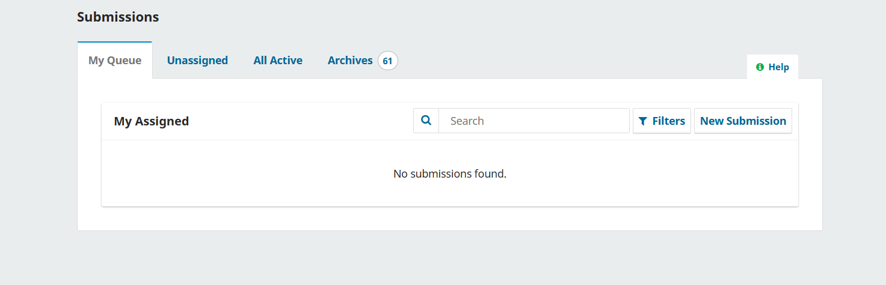

Fig. 6 Submission page

Your submission starts with step 1(see Fig.7) where you need to select the conference section where you would like to participate. There is a drop-down menu and you just select one. After that, you should verify if your work meets all requirements and check the boxes below.

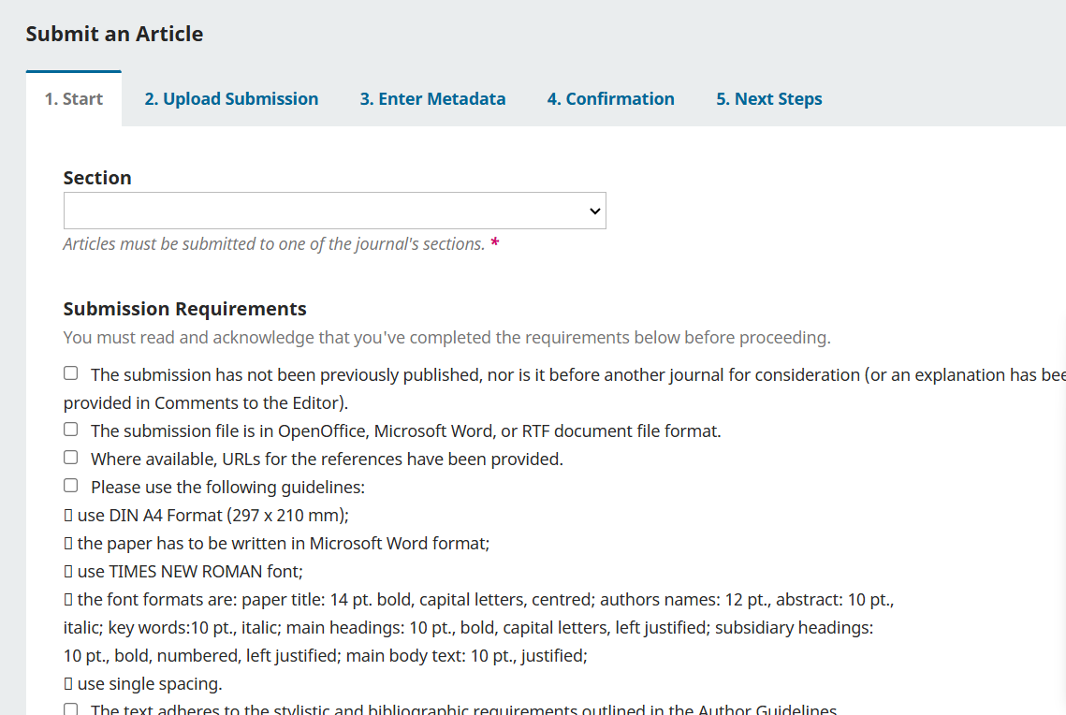

Fig.7 Submission – step-by-step

You should follow the steps as they are defined and you must fill in all information required, else you cannot go to the next step. The abstract will be uploaded as a word file in the step 2 (name your file as Name_abstract, using the name of the first author) and also you will be asked to insert in step 3 Enter Metadata, filling in the window, see Fig. 8. You will be notified via platform if your abstract was accepted and advised to upload the full manuscript and only after your paper will be sent for review.The manuscript for review should be blind (no names of contributors).

You can upload the manuscript in the same session with the abstract but the first evaluation will be on your abstract and only after acceptance the manuscript will be sent to reviewers.

Your initial manuscript should be blind (no author names in the docx. file) because the review is a double-blind kind of evaluation. After you address the reviewers' comments and suggestions you will upload the final version of your manuscript which will include all authors' names and affiliations (see the ICMIE template).

All submissions will be checked against plagiarism, and all authors should declare if they have used AI text gen tools.

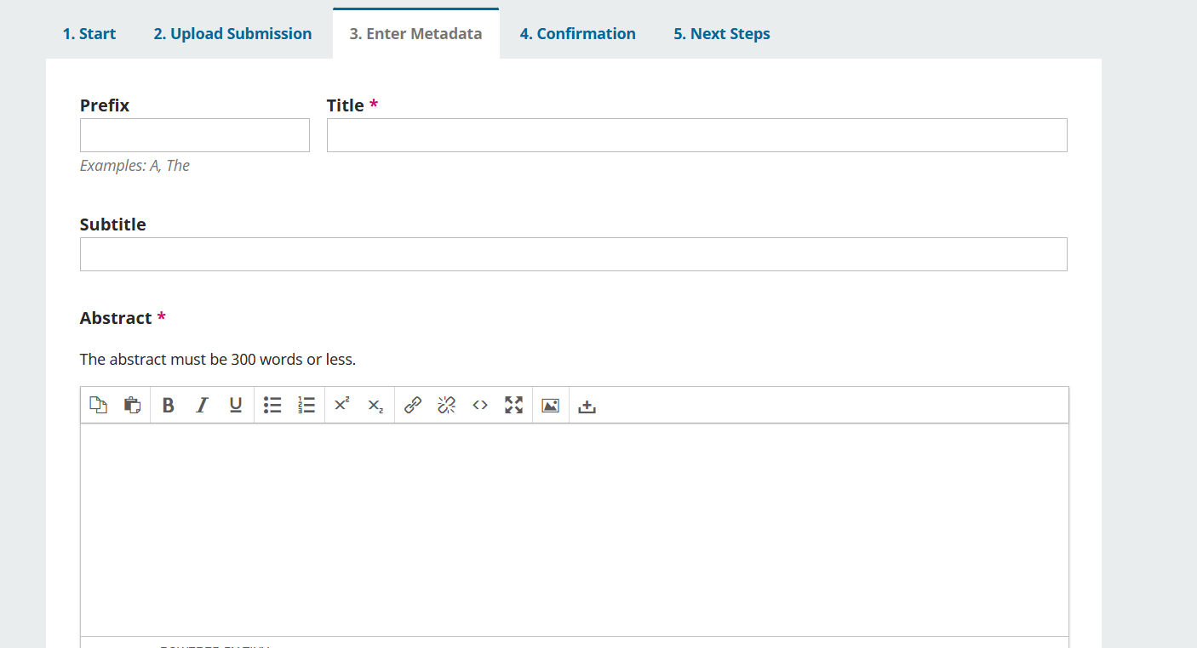

Fig. 8 Submission process – inserting the Metadata

Be careful when you insert the names of the contributors - you need to list them in the same order as they appear in the paper.

Looking forward to receiving your manuscripts!

Good luck along the way!